

**Assignment : - 1**

**NAME :- JANI SIDHDHARTH V.**

**Module :- 1 Understanding of hardware and its components**

**Section 1 :- multiple choice**

1. **Which of the following is NOT a component of the CPU ?**
2. **ALU**
3. **RAM**
4. **CU**
5. **1 AND 3 Both**

**Ans :-** 2. RAM – Random access memory (RAM) is not a CPU Component because it is located on the motherboard.

1. **What is the function of RAM in a computer ?**

**Ans :-** Random Access Memory (RAM) is a computer's short-term memory that stores data and programs that are being actively used. RAM's main function is to allow the computer to quickly read and write data, which is essential for a computer's performance.

**3. Which of the following is a primary storage device?**

**1. HDD**

**2. SSD**

**3. SD card**

**4. 1 and 2 both**

**Ans :- 1.** 1 and 2 both. HDD and SSD card are primary storage devices whereas SD is secondary storage device

**Note :- correct answer is RAM ( Random access memory ) , but option is**

**HDD,SSD And SD card is secondary memory**

**4.What is the purpose of a GPU ?**

**Ans :-** A graphics processing unit (GPU) is a hardware component that's designed to handle graphics-related tasks, such as rendering images, videos, and animations. and like machine learning (ML), video editing, and high performance computing (HPC).

**Section 2 :- true or false**

**5.**  **The motherboard is the main circuit board of a computer**

**where other components are attached.**

**Ans :-** True

**6. A UPS (Uninterruptible Power Supply) is a hardware**

**device that provides emergency power to a load when the input power**

**source fails.**

**Ans :-** True

**7. An expansion card is a circuit board that enhances the functionality**

**of a component.**

**Ans :-** True

**Section 3 :- Short answer**

**8.Explain the difference between HDD and SSD.**

**Ans :-**

|  |  |
| --- | --- |
| HDD | SSD |
| Random access time 5-10 ms. | Random access time 0.1 |
|  |
| Low reliability | high reliability |  |
|  |
| Relatively large and heavy | Small and light weight. |  |
|  |
| 50MB/s to 100MB/s | 100MB/S to 500MB/s |  |
|  |
| read latency time high. | Read latency time very low |  |
|  |
| 6 to 12 watts | Power Consumption 2 watts. |  |
|  |

**9. Describe the function of BIOS in a computer system.**

**Ans** :- BIOS, or Basic Input/Output System, is a program that controls a computer's hardware and software, and is responsible for many of the computer's basic functions.

1.Booting 2. Security

3. Hardware configuration 4. System configuration

5. Data flow 6. Diagnostic tools

**10.** **List and briefly explain three input devices commonly used with**

**computers.**

**Ans :-** Input devices :

1. Key board
2. Mouse
3. Scanner
4. Key board :- A keyboard's primary use is to input data into a computer, such as letters, numbers, and symbols.
5. Mouse :- A mouse is a small device that a computer user pushes across a desk surface in order to point to a place on a display screen and to select one or more actions to take from that position.
6. Scanner :- A scanner is a device that captures images from photographic prints, posters, magazine pages and similar sources for computer editing and display.

**Section 4: Practical Application**

**11. Identify and label the following components on a diagram of a motherboard:**

**● CPU ●SATA connectors**

**● RAM slots ●PCI-E slot**

SATA connectors

**Ans:-**

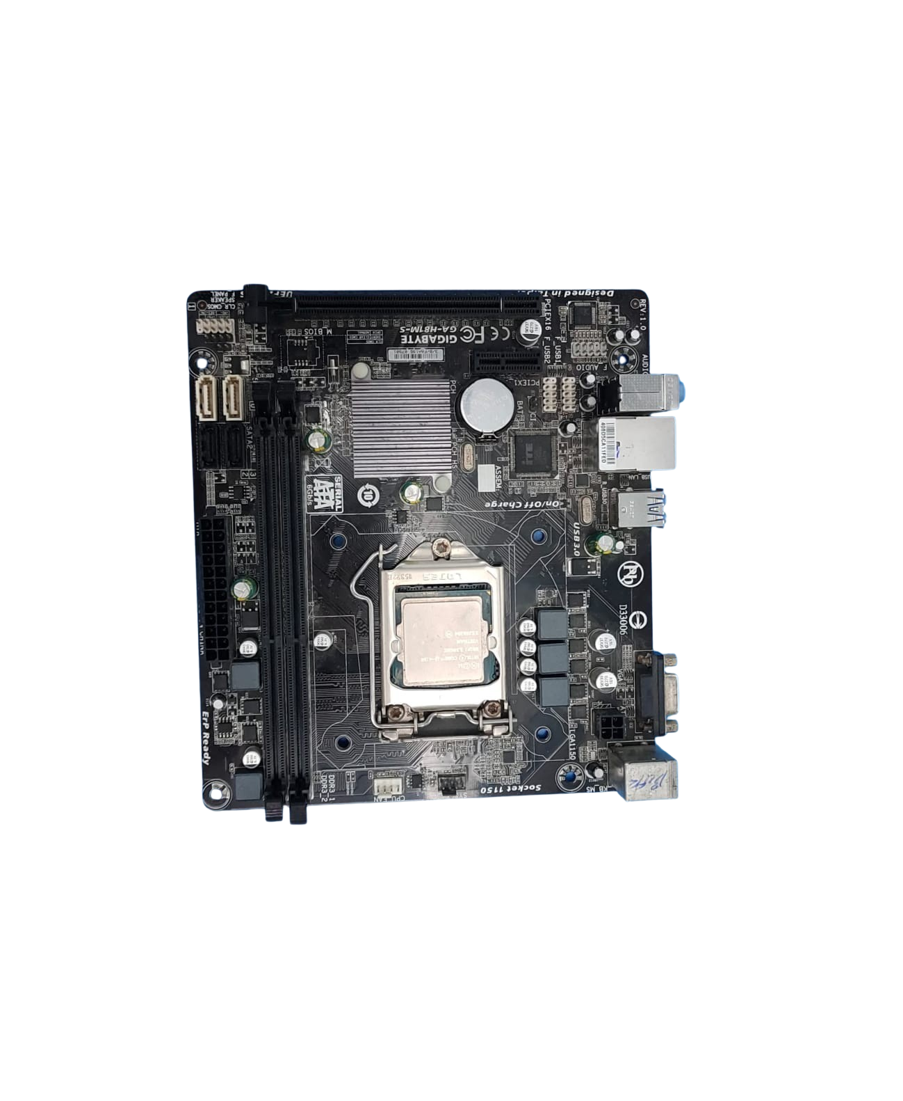

RAM slot

CPU

PCI-E slot

**12. Demonstrate how to install a RAM module into a computer.**

**Ans**:- Installing a RAM module into a computer is a straightforward process. Here’s a step-by-step guide:

Tools You’ll Need:

- A compatible RAM module

- A screwdriver (if necessary)

- Anti-static wrist strap (optional but recommended)

Step 1: Prepare Your Workspace

1. Power Off the Computer: Shut down the computer and unplug it from the wall.

Step 2: Open the Computer Case

2. Locate the RAM Slots: Find the RAM slots on the motherboard. They are typically located near the CPU.

Step 3: Remove Existing RAM (if necessary)

2. Lift the RAM Module: Carefully pull the module out of the slot.

Step 4: Insert the New RAM Module

1. Align the Notch: Position the new RAM module so that the notch on the module lines up with the notch in the RAM slot.

Step 5: Close the Computer Case

Step 6: Power On the Computer

1. Turn On the Computer: Press the power button.

Step 7: Boot into the Operating System

1. Exit BIOS/UEFI: Save any changes and exit.

2. Verify in OS: Once booted into your operating system, check the system properties to ensure the RAM is detected.

**Section 5: Essay**

**13.Discuss the importance of proper cooling mechanisms in a computer system. Include examples of cooling methods and their effectiveness.**

**Ans**:- 3 types of cooling systems in a computer

1. Air types of cooling system

These are the most common type of cooling systems in most PCs. they are also the cheapest. They have a heat sink to dissipate heat and a fan to blow fresh cool air into them. These types of systems make noise due to fan rotation.

1. Liquid types of cooling system

They are mostly used for high-end computers like gaming which carry out many operations. They are better at cooling, and have less noise than the air type but are bulky in size and expensive.

Comparison between air vs liquid computer cooling

3 Passive Cooling

Description: Relies on natural convection and conduction without the use of fans or pumps. Large heat sinks dissipate heat directly into the environment.

Effectiveness: Very quiet and can be effective in low-power or low-heat scenarios. However, it is generally insufficient for high-performance applications where heat generation is significant.

**14.Explain the concept of bus width and its significance in computer architecture.**

**Ans :- two types of bus**

Serial Bus:

A serial bus is a type of communication system where data is transmitted sequentially, one bit at a time, over a single communication line or channel. It contrasts with parallel buses, where multiple bits are sent simultaneously over multiple lines. Serial buses are often used in applications where simplicity, cost-effectiveness, or long-distance communication are important factors.

Parallel Bus:

A parallel bus is a communication system where multiple bits of data are transmitted simultaneously over several parallel lines or channels. Each bit of the data word travels on its own dedicated line within the bus. Parallel buses can offer faster data transfer rates compared to serial buses but may require more hardware and are typically used over shorter distances due to synchronization issues and signal integrity concerns.